The fairandfunky Fairtrade Conference for Secondary Schools – March 4th 2020

Bookings for the fairandfunky Fairtrade Conference for Schools: are NOW OPEN!

We are inviting your school to bring up 10 students and 2 teachers at a cost of £145* – places are limited so please do BOOK NOW to avoid disappointment.

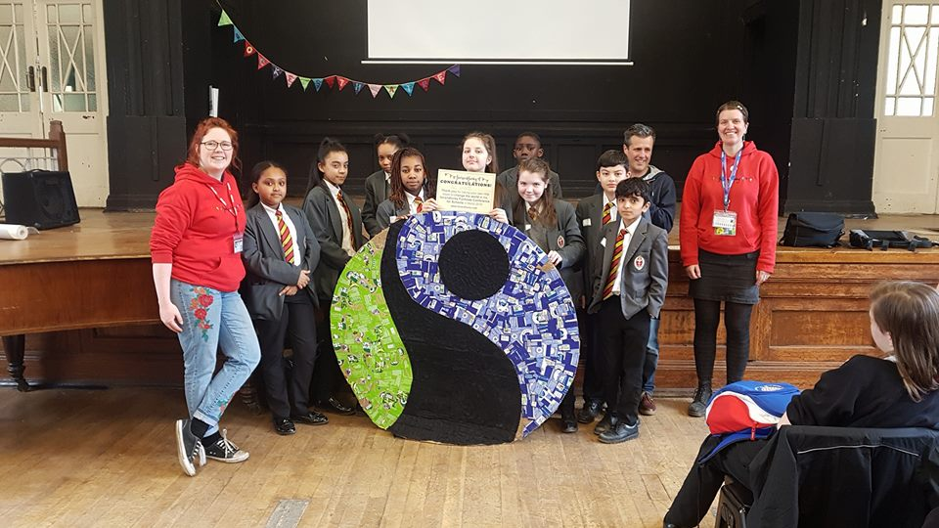
The fairandfunky Fairtrade Conference for Schools at Honley High School brings together Secondary Schools from across Yorkshire to ignite enthusiasm and interest in both pupils and teachers for local and global sustainability.

The conference will link with the Eco-Schools programme and Fairtrade Schools Award, providing evidence for each of these award schemes. Interactive workshops will develop a deeper understanding on trade justice issues, citizenship, co-operative values in business, and the Fairtrade system.

Leading workshop providers and business leaders from fairandfunky, Rose Condo, Trading Visions and Central England Co-operative - will facilitate interactive sessions through drama, debate and presentations, involving: global supply chains, international trade relations, food sustainability, and co-operative business – providing plenty of food for thought!
Each student will take action for Fairtrade in the following workshops:

Values in Supply Chains | Central England  Co-operative | Discover how the Co-operative plays its part in supporting Fairtrade and other co-operatives. Design your own chocolate wrapper highlighting the values.
Take a Fairtrade Chocolate break | Trading Visions | The fascinating journey of ‘Bean to Bar’; learning about cocoa producers in Ghana, and tasting Fairtrade chocolate!
Fair/Unfair?  You decide | Rose Condo | Debate the future of Fairtrade in creative and dramatic activities which will provoke an emotional response to Fairtrade.
Fairtrade and Sustainability | fairandfunky | A focus on sustainability and Fairtrade – discover ways to make ethical choices when it comes to fashion, with discussion, debate, video and practical activities.

“An excellent conference – interesting, informative and lots of fun; diverse and educational, the conference really involved our pupils and will help kickstart activities back at school.”
Feedback from fairandfunky Fairtrade Conference 2019.

We’d be delighted to welcome your school to the conference and look forward to hearing from you,

Helen and Sophie www.fairandfunky.com
----------------------------------------------------------------------------------------------------------------------------------------------------------
To confirm your booking please complete this form and return with payment
To: fairandfunky, 78A Greenfield Road, HOLMFIRTH. HD9 2LA
Name of School
Main contact
E-mail

Payment details | Please tick
Cheque enclosed for £145 Cheques made payable to fairandfunky CIC
* Cheque enclosed for £130.50 10% early bird discount
Please note: a 2nd form will follow closer to the time to confirm names of delegates attending the event.

