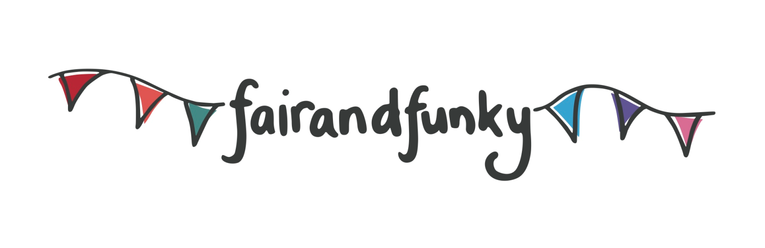

The fairandfunky Sustainable Schools Conference
Friday 7th June 2019: Indian Muslim Welfare Society (IMWS), Batley. WF17 7AA.

Bookings for the fairandfunky Sustainable Schools Conference are NOW OPEN!

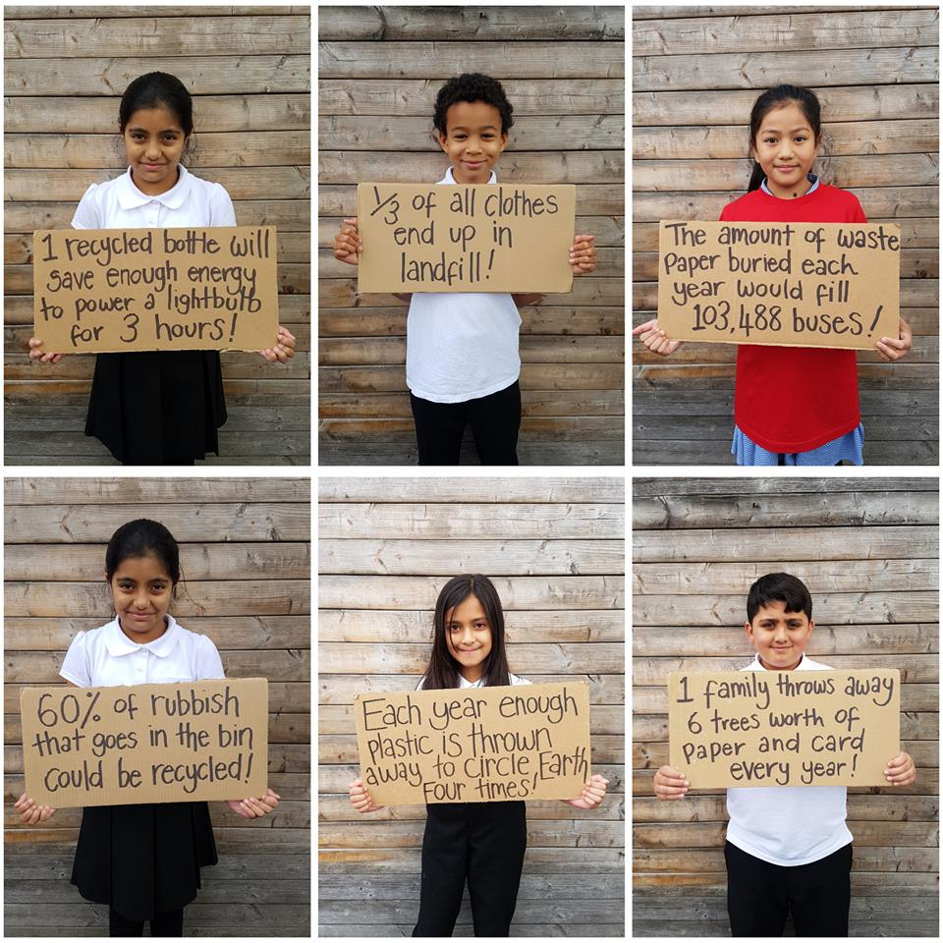
The fairandfunky Sustainable Schools Conference brings schools from diverse communities together to celebrate World Environment Day and learn about Sustainable Development Goals (SDGs) in fun, creative and engaging ways giving innovative ideas for teachers and students to take learning back to the school environments and link to the Eco-Schools programme and beyond!

The Conference teaches on 4 SDGs: Clean Water – workshops from Water Explorers empower participants to ensure access to safe water sources and sanitation for all; Clean Energy – workshops with Energy Heroes inspire delegates to use energy in a way which is sustainable for all; Life on Land – innovative drama workshops from Pockets Theatre show how communities can live sustainably and halt biodiversity loss; Climate Action – fairandfunky lead creative arts workshops showing how we can all take action to tackle climate change and its impacts.

The conference will link with the Eco-Schools programme (see table below) providing evidence for this prestigious award scheme.

All students will create individual recycled artworks to take home, along with a pack of wildflower seeds and other eco-goodies. The event will close with a Q&A and certificate presentations with a very important guest. During lunch delegates will be able to take part in a variety of Fairtrade activities, and enjoy networking opportunities with workshop providers and shop in the ethical marketplace.

Each student will take action for local and global sustainability in the following workshops:
SDG 15 Life on Land  Choices, Choices! | Pockets Theatre Global Citizenship | Create dramatic performance pieces as you step into an imaginary meeting of powerful people and decide the future of your town! Will it be sustainable?
SDG 13 Climate Action  Litter Bugs | fairandfunky Litter and Marine | Create artworks from recycled materials and discover how recycling your rubbish can combat climate change.
SDG 7 Clean Energy  Renewable Pursuits | Energy Heroes Energy | Through maths games, quizzes and activities discover how to become Energy Heroes who take action to save the world!
SDG 6 Clean Water  Rap Tap Tap! | Water Explorers Water | Uncover some incredible facts about water around the world and create a drip, drop, tip, tap RAP to encourage others to save water too.
“Children and staff have always come back from a fairandfunky conference buzzing with ideas and knowledge........an excellent way to engage our children with crucial world issues of sustainability.”
Alex Beaumont, Headteacher at Meltham C of E School.

IMPORTANT INFORMATION: PLACES ARE LIMITED. PLEASE BOOK NOW TO AVOID DISAPPOINTMENT.
Each delegate receives an event bag filled with eco-goodies!
Date | 7th June 2019
Location | IMWS Centre, Batley
Time | Registration from 9:15am - Event opens - 9:30am  Event closes - 14:30pm
Cost | £125 per school – this includes 8 pupils and 2 teachers
Lunch | Please bring a packed lunch for each participant

Booking form available from sophie@fairandfunky.com

