The fairandfunky Fairtrade Conference for Schools
Thursday 1st March 2018: Honley High School, Station Road, Holmfirth. HD9 6QJ.

BOOK NOW for the fairandfunky Fairtrade Conference for Secondary Schools

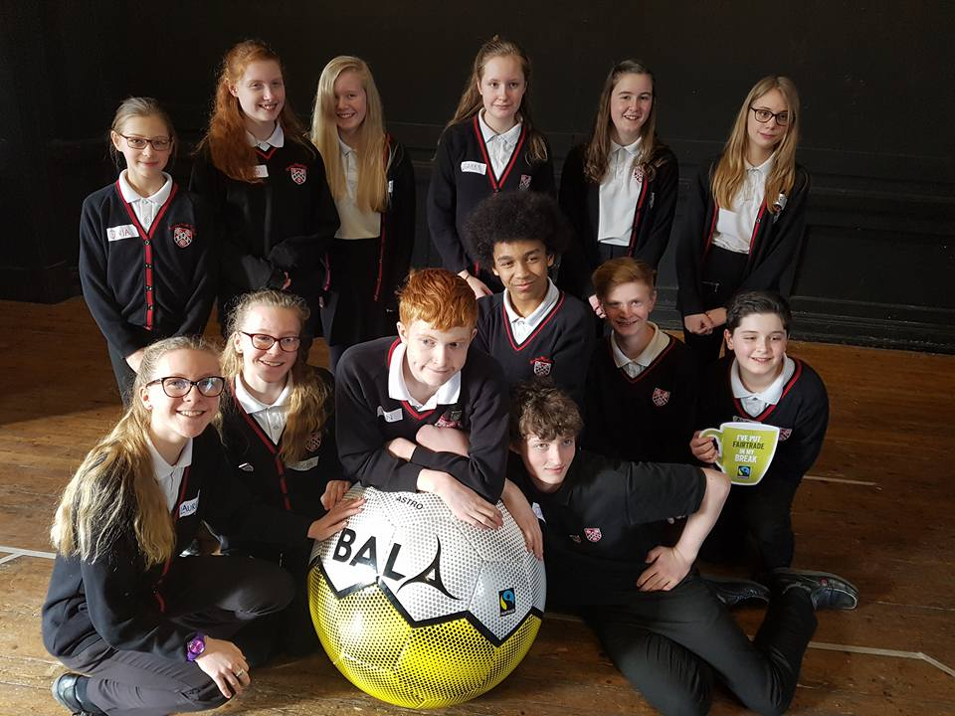
The fairandfunky Fairtrade Conference for Schools brings together Secondary Schools from across Yorkshire to ignite enthusiasm and interest in both pupils and teachers for local and global sustainability.

The conference will link with the Eco-Schools programme and Fairtrade Schools Award, providing evidence for each of these award schemes. Interactive workshops will develop a deeper understanding on trade justice issues, citizenship, co-operative values in business, and the Fairtrade system.

Leading workshop providers and business leaders from fairandfunky, Upcycle Fashion, Koolskools, Trading Visions and Suma Wholefoods - will facilitate interactive sessions through drama, debate and presentations, involving: global supply chains, international trade relations, food sustainability, and co-operative business – providing plenty of food for thought!

Each student will take action for Fairtrade in the following workshops:
The Trading Game | Suma Wholefoods | Discover the world of trading and how co-operative values are the bedrock of this multi-million pound business.
Take a Fairtrade Chocolate break | Trading Visions | The fascinating journey of ‘Bean to Bar’; learning about cocoa producers in Ghana, and tasting Fairtrade chocolate!
Cotton on To Fairtrade | KoolSkools | An in-depth look at the Fairtrade benefits to cotton farmers, and at the way in which the social premium helps communities' development.
Fairtrade and Sustainability | Upcycle Fashion | A focus on sustainability and Fairtrade – discover ways to make ethical choices when it comes to fashion, with discussion, debate, action and role-play.

NEW FOR 2018: Teacher CPD with fairandfunky
How to become a Fairtrade School and reaching the Fair Achiever Award
Teaching staff are invited to attend a one hour workshop facilitated by fairandfunky on the steps to make your Fairtrade Schools journey. With expert knowledge and case studies from local schools you will gain invaluable advice and top tips on gaining the Fairtrade School Awards, plus brilliant resources to make it happen where you are.

Over lunch all delegates can enjoy networking with workshop facilitators and will be able to shop in the ethical marketplace. The conference will close with certificate presentations from The Mayor of Kirklees.
-----------------------------------------------------------------------------------------------------------------------------------------------------------
IMPORTANT INFORMATION: PLACES ARE LIMITED. PLEASE BOOK NOW TO AVOID DISAPPOINTMENT.
Each student delegate will receive an event bag with Fairtrade goodies!

Date | 1st March 2018
Location | Honley High School
Time | Registration from 9:15am - Event opens - 9:30am  Event closes - 14:30pm
Cost | £145 per school – this includes 10 students and 2 staff
Lunch | Please bring a packed lunch for each participant

Please email helen@fairandfunky.com for a booking form.
Conference Champion Sponsors

