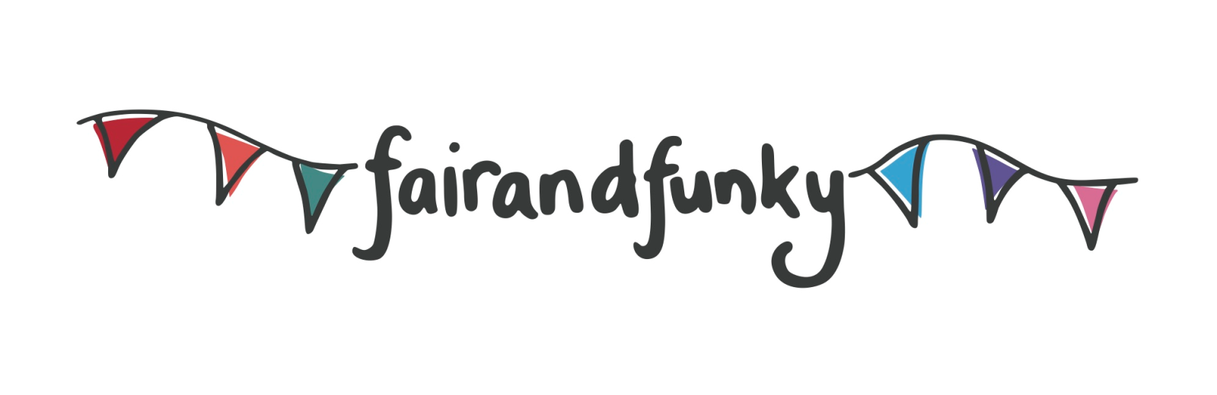

The fairandfunky GO GREEN Conference for Schools
Friday 10th June 2016: Northfield Hall, Huddersfield, HD2 1GS.

Bookings for the fairandfunky GO GREEN Conference for Schools are NOW OPEN!

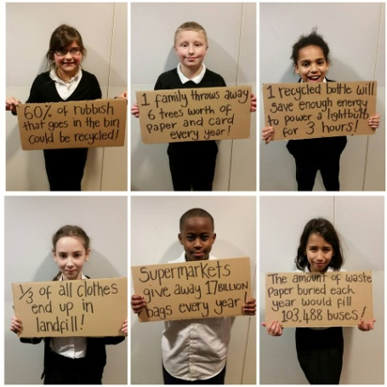
The fairandfunky GO GREEN Conference brings together Primary Schools from across Kirklees to celebrate World Environment Day. The conference will ignite enthusiasm and interest in both pupils and teachers of sustainability issues from Eco-Schools and enable schools to progress on their Eco-Schools journey.
Interactive workshops involving drama, recycling, gardening, and muddy fingers from fairandfunky, Grow To School, Pockets Theatre and West Yorkshire Bee Keepers will inspire delegates to GO GREEN! This is the first conference in Kirklees to combine sustainability and the arts, offering professional development for teachers and innovative learning for students.

The conference is supported by Eco-Schools, and will help schools progress on their ‘Eco-Schools’ journey as well as contributing to the Arthur Halliwell Award from Kirklees Sustainable Schools. During lunch delegates will be able to take part in a variety of activities and enjoy networking opportunities with workshop providers and Eco-Schools staff.

Each student will GO GREEN in the following workshops:
Water, Water everywhere but not a drop to drink! | Pockets Theatre | Create dramatic performance pieces in response to considering a world without water.
Litter Bugs | fairandfunky | Create individual artworks from recycled materials and discovering how to recycle your rubbish.
Brilliant Biodiversity | Grow To School | Explore the wonderful array of habitats on your doorstep as you unearth brilliant biodiversity!
BEE wise! | West Yorkshire Bee Keepers | Discover why bees are so important, how to identify them and see the world like a bee! Also includes tips on bringing bees to your school.
“Children and staff have always come back from a fairandfunky conference buzzing with ideas and knowledge. We have found them an excellent way to engage our children with crucial world issues of Fairtrade and sustainability.” Alex Beaumont, Headteacher at Meltham C of E School.

IMPORTANT INFORMATION: PLACES ARE LIMITED. PLEASE BOOK NOW TO AVOID DISAPPOINTMENT.
Each delegate receives an event bag filled with eco-goodies and each school will receive a pack of Seedball wildflower seeds at the conference! All this is included in the cost to the school.

Date | 10th June 2016
Location | Northfield Hall
Time | Registration from 9:15am - Event opens - 9:30am  Event closes - 14:30pm
Cost | £120 per school – this includes 8 pupils and 2 teachers
EARLY BIRD BOOKING OFFER – £110 per school if you book before the Spring Half Term
Lunch | Please bring a packed lunch for each participant

Booking form available from sophie@fairandfunky.com
www.fairandfunky.com

