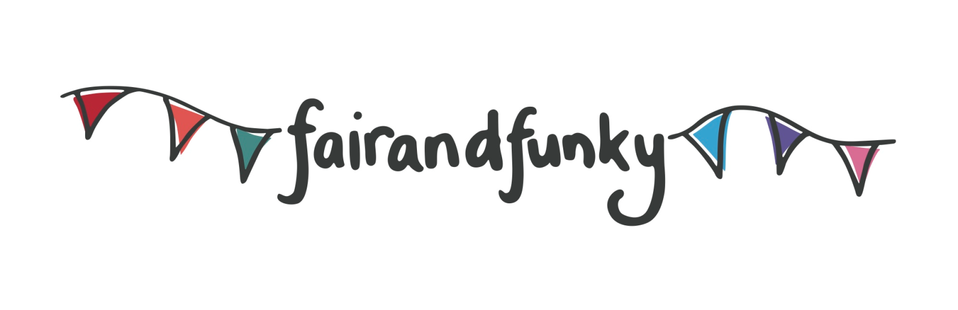

The fairandfunky GO GREEN Conference for Schools
Friday 10th June 2016: Northfield Hall, Huddersfield, HD2 1GS.

BOOKING FORM: PLEASE RETURN ASAP PLACES ARE LIMITED
BOOK BEFORE THE SPRING HALF TERM TO RECEIVE A PRIORTY DISCOUNT

Name of School

Main contact |  | E-mail

Name of student | Year Group | Photograph permission  Photos will be taken by fairandfunky to use on social media and www.fairandfunky.com

Name of staff attending | Email contact details

Payment details | Please tick
Cheque enclosed for £120
Cheque enclosed for £110 – reduction for early bird booking
Cheques made payable to fairandfunky CIC

Please return form with payment to:
fairandfunky, 82B Woodhead Road, HOLMFIRTH. HD9 2PR

