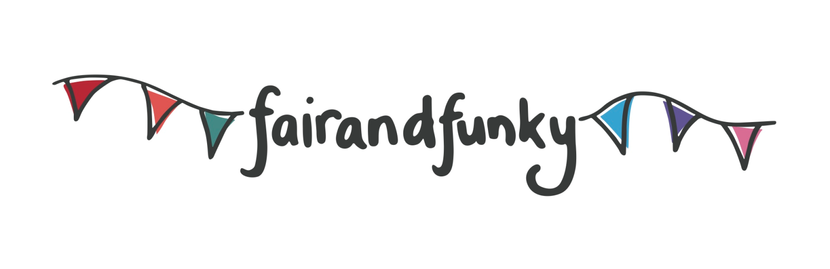
Conference Champion Sponsors

The fairandfunky Fairtrade Conference for Schools: ‘Around the World.’
March 10th 2016: Indian Muslim Welfare Society, Batley. WF17 7AA

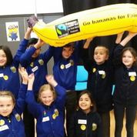
Bookings for the fairandfunky Fairtrade Conference for Schools: ‘Around the World’ at IMWS in Batley, are NOW OPEN!

The fairandfunky Fairtrade Conference: ‘Around the World’ brings together Primary Schools from across North Kirklees to celebrate Fairtrade Fortnight. The conference will ignite enthusiasm and interest in both pupils and teachers to maintain awareness and understanding of Fairtrade and how it can be taught within busy classrooms.
Interactive workshops involving creative arts, real life stories, and chocolate tasting from fairandfunky, The Fairtrade Foundation, Couer de Xocolat and Fair Grounds will take delegates around the world with Fairtrade: from Ghana to India, Nepal and Pakistan.

The conference is supported by The Fairtrade Foundation and Eco-Schools, and will help schools progress on both the Fairtrade Schools Award and ‘Eco-Schools’ journey. During lunch delegates can browse information stands, take part in lunchtime activities and shop with fairandfunky in the ethical marketplace. The event will close with certificate presentations.

Each student will take part in the following workshops:
Around the whole world! | Fairtrade Foundation | Do you know how many Fairtrade products there are? Or where they are all from? You will after your trip around the world!
Around the world to Pakistan | fairandfunky | Play Fair! Meet the makers of the Fairtrade football and learn about their lives in Pakistan.
Around the world to Ghana | Coeur De Xocolat | The journey of ‘Bean to Bar’; learning about producers in Ghana, and tasting Fairtrade chocolate!
Around the world to the Philippines | Fair Grounds | Learn about the Philippines and the recycled newspaper products made there,then have a go at making some yourself!
“Excellent organisation from fairandfunky, the conference was brilliant. The children were all so engaged throughout the whole day.” Feedback from fairandfunky One World Week Conference.

IMPORTANT INFORMATION: PLACES ARE LIMITED. PLEASE BOOK NOW TO AVOID DISAPPOINTMENT.
Each delegate receives an event bag filled with Fairtrade goodies and each school will receive a Fairtrade football at the conference! All this is included in the cost to the school.

Date | 10th March 2016
Location | Indian Muslim Welfare Society, Batley. WF17 7AA
Time | Registration from 9:15am - Event opens - 9:30am  Event closes - 14:30pm
Cost | £120 per school – this includes 8 pupils and 2 teachers
EARLY BIRD BOOKING OFFER – £110 per school if you book before the end of the Autumn term
Lunch | Please bring a packed lunch for each participant

Booking form available from sophie@fairandfunky.com
www.fairandfunky.com

