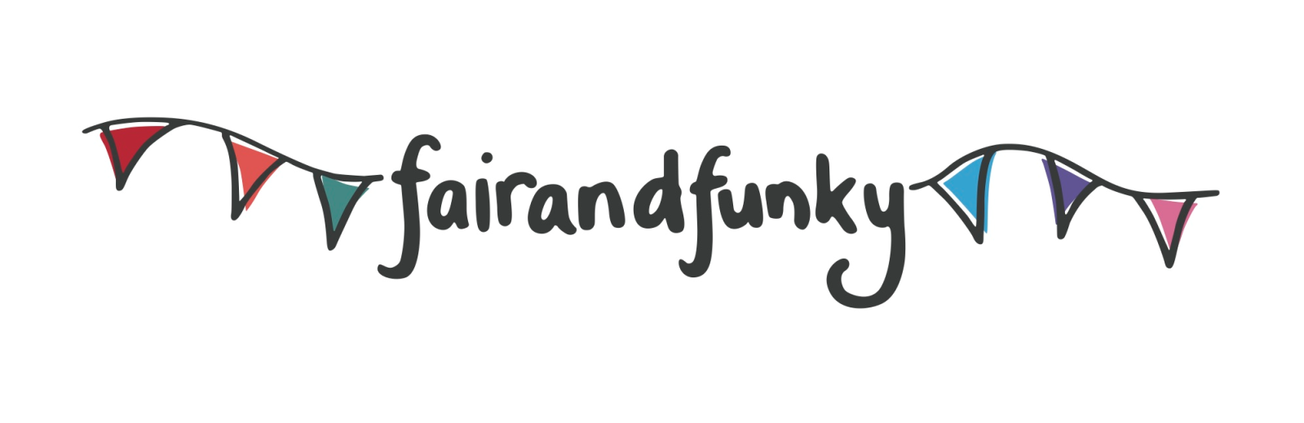

The fairandfunky Sustainable Schools Conference
Friday 6th October 2017: Indian Muslim Welfare Society (IMWS), Batley. WF17 7AA.

Bookings for the fairandfunky Sustainable Schools Conference are NOW OPEN!

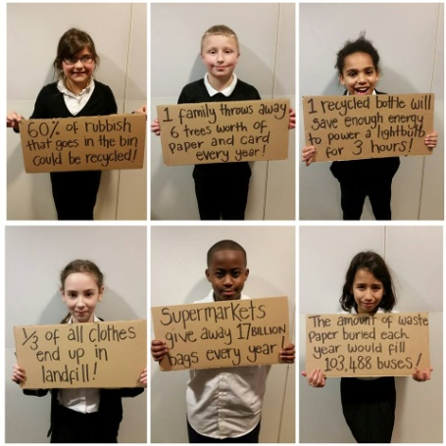
The fairandfunky Sustainable Schools Conference brings together Primary Schools to celebrate World Environment Day. The conference will ignite enthusiasm and interest in both pupils and teachers for local and global sustainability.

The conference will link with the Eco-Schools programme, Food For Life and Fairtrade Schools Award, providing evidence for each of these award schemes.

All students will create individual recycled artworks to take home, along with a pack of wildflower seeds and other eco-goodies. The event will close with a Q&A and certificate presentations from Tracy Brabin MP.

Leading workshop providers – fairandfunky, Grow To School, Pockets Theatre and LoveBread - will facilitate interactive sessions involving drama, recycling, local food and muddy fingers – providing plenty of food for thought!

During lunch delegates will be able to take part in a variety of Fairtrade activities, enjoy networking opportunities with workshop providers and Eco-Schools staff, and shop in the ethical marketplace.

Each student will take action for local and global sustainability in the following workshops:
Choices, Choices! | Pockets Theatre | Create dramatic performance pieces as you step into an imaginary meeting of powerful people and decide the future of your town! Will it be sustainable?
Litter Bugs | fairandfunky | Create individual artworks from recycled materials and discovering how to recycle your rubbish.
Brilliant Biodiversity | Grow to School | Explore the wonderful array of habitats on your doorstep as you unearth brilliant biodiversity and create your own pond.
Flour Power! | LoveBread | Delve into dough to discover the world of bread – at your fingertips! Find out about milling and processing and where your food comes from.
“Children and staff have always come back from a fairandfunky conference buzzing with ideas and knowledge. We have found them an excellent way to engage our children with crucial world issues of Fairtrade and sustainability.” Alex Beaumont, Headteacher at Meltham C of E School.

IMPORTANT INFORMATION: PLACES ARE LIMITED. PLEASE BOOK NOW TO AVOID DISAPPOINTMENT.
Each delegate receives an event bag filled with eco-goodies and each school will receive a pack of wildflower seeds at the conference!

Date | 6th October 2017
Location | IMWS Centre, Batley
Time | Registration from 9:15am - Event opens - 9:30am  Event closes - 14:30pm
Cost | £120 per school – this includes 8 pupils and 2 teachers
Lunch | Please bring a packed lunch for each participant

Booking form available from helen@fairandfunky.com
www.fairandfunky.com

