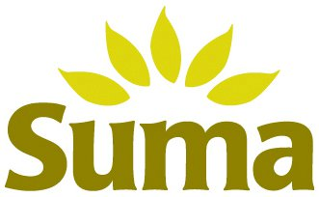

Conference Champion Sponsors

The fairandfunky Fairtrade Conference for Schools
Friday March 2nd 2018: The Creative and Media Studio School, Huddersfield. HD5 9NY

Bookings for the fairandfunky Fairtrade Conference for Schools: are NOW OPEN!

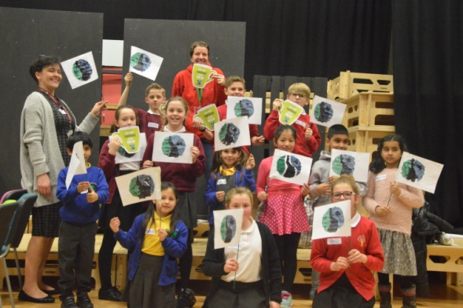
The fairandfunky Fairtrade Conference: brings together Primary Schools from across Kirklees to celebrate Fairtrade Fortnight. The conference will ignite enthusiasm and interest in both pupils and teachers to maintain awareness and understanding of Fairtrade and how it can be taught within busy classrooms.
Interactive workshops involving creative arts, drama, real life stories, and chocolate tasting from fairandfunky, Fair Grounds, Couer de Xocolat and Suma Wholefoods will take delegates on a Fairtrade Adventure and discover how to take a break with Fairtrade!

The conference is supported by The Fairtrade Foundation and Eco-Schools, and will help schools progress on both the Fairtrade Schools Award and ‘Eco-Schools’ journey. During lunch delegates will be able to enjoy networking opportunity with sponsors and workshop providers and shop in the ethical marketplace. The event will close with certificate presentations from Thelma Walker MP.

Each student will take part in the following workshops:
Fairtrade Poetry | Fair Grounds | Inspired by the lives of Fairtrade producers around the world, create (and perform) group poetry pieces.
The Power of YOU! | fairandfunky | Discover the power of the consumer & how our shopping makes a difference. All students make a Fairtrade wallet to take home!
Take a Fairtrade Chocolate Break | Coeur De Xocolat | Head to Ghana and learn about cocoa producers, how chocolate is produced, and taste Fairtrade chocolate!
The Fairtrade Journey | Suma Wholefoods | Discover the whole journey and supply chain of Fairtrade products from farm to fork. All students will make their very own Suma lorry to take home!

“An excellent, well organised conference with really interesting workshops motivating and engaging our students on Fairtrade.” Spring Grove Junior School

“A fantastic conference – even better than we thought it would be! Excellent workshops engaging all children” Pentland I&N School

Feedback from fairandfunky Fairtrade Conference 2017.

IMPORTANT INFORMATION: PLACES ARE LIMITED. PLEASE BOOK NOW TO AVOID DISAPPOINTMENT.
Each delegate receives an event bag filled with Fairtrade goodies!

Date | Friday 2nd March 2018
Location | Creative Media and Studio School, Huddersfield
Time | Registration from 9:15am - Event opens - 9:30am  Event closes - 14:30pm
Cost | £120 per school – this includes 8 pupils and 2 teachers
Lunch | Please bring a packed lunch for each participant

Booking form available from sophie@fairandfunky.com
www.fairandfunky.com

